**NAME**: S SHELVASUJITH

**REG NO**: 192124191

|  |  |
| --- | --- |
| **Ex. No. 8** | **DATA LINK LAYER TRAFFIC SIMULATION OF ARP** |
| **Date:6-10-2023** |

### AIM:

To configure DDL using cisco packet analysis of ARP.

### REQUIREMENTS:

1. End device - They are the devices through which we can pass message from one device to another and they are interconnected.
2. Switch/Hub - Interface Between two devices.
3. Cable - Used to connect two devices.

Adress Resolution Protocol (ARP) is the protocol that is used to find the MAC address of the device whose IP address is known. The ARP commands helps to check or delete the entries available at the end devices. The ARP request is broadcast message and the device with required IP replies back with the MAC address. To know the IP address of the know MAC address, Reverse Address Resolution Protocol (RARP) is used.

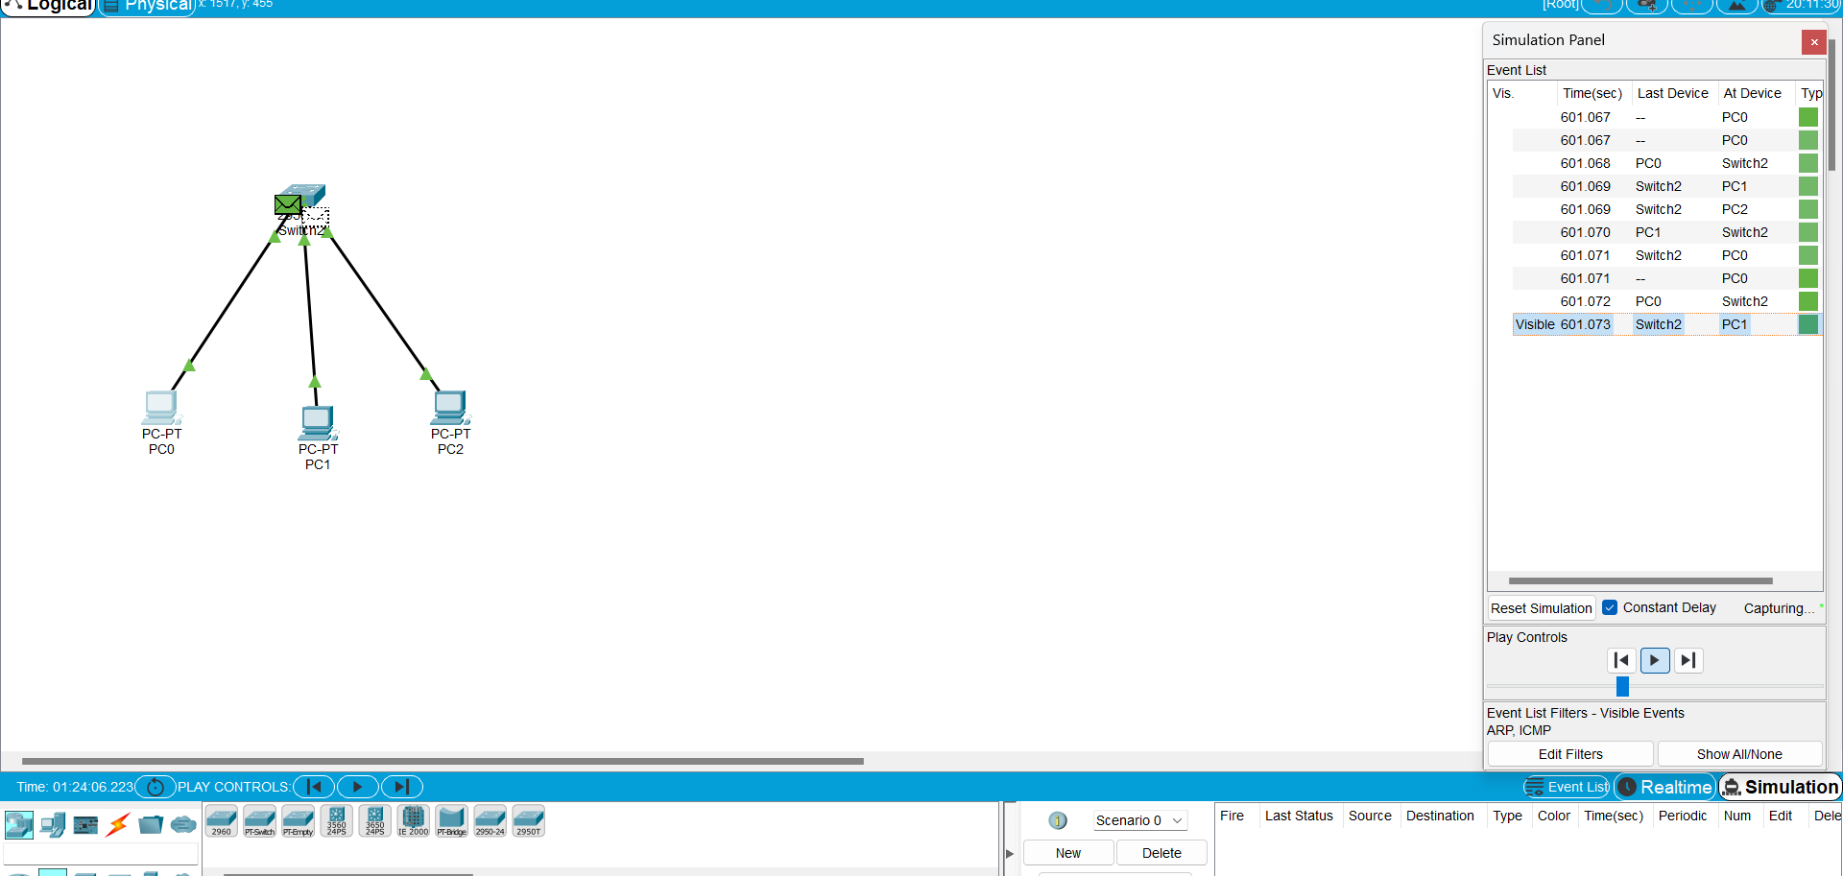

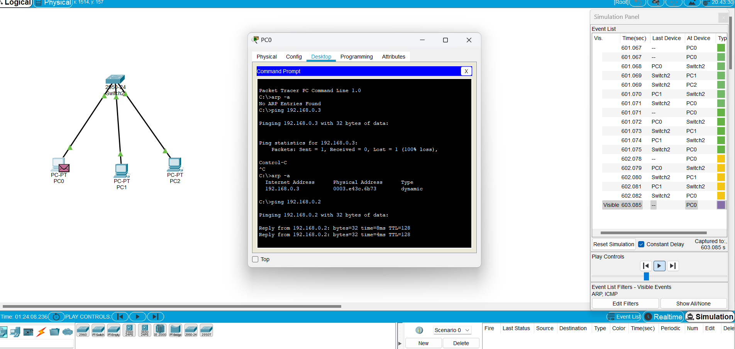

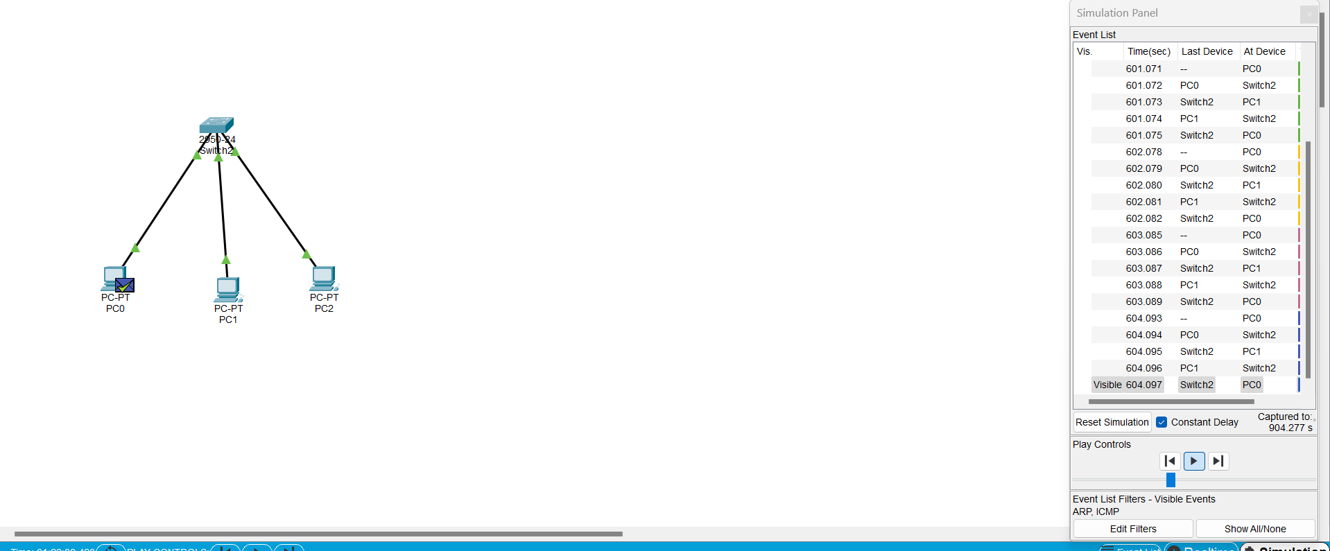

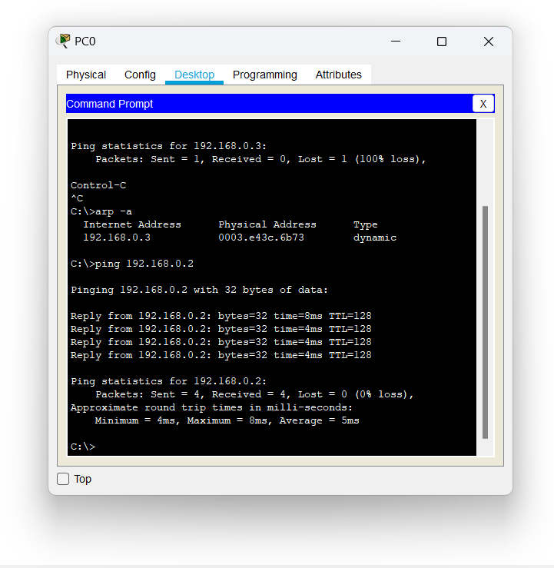

**PROCEDURE**

STEP 1: Click on end devices, select generic Pc’s drag and drop it on the

window. Click on SWITCH drag and drop it on the window.

STEP 2: Select the straight through cable and connect all end device to switch. Assign the IP address for all end devices. (Double click the end device Select →

desktop → IP configuration static)

STEP 3: Now set the IP address to Host A (192.168.1.1) in static mode. Similarly set IP address for Host B (192.168.1.2) and Host C (192.168.1.3)

STEP 5: To view the IP address, give ipconfig command in command prompt. Using ping command, we can establish communication between two host devices.

STEP 6: Now display the packet transmission in simulation mode.

**RESULT**

Configuration of DDL using cisco packet analysis of ARP is successful.